Name____Key_____________________________

**ABE 30300 – Fall 2017**

**QUIZ 4 – Fall 2017 - Use moderate handwriting size, enough to be legible**

**Question 1**. Circle either **True (T)** or **False (F)** for the following statements [**30 marks**]

T F In an oscillatory test, the storage modulus G’ of a viscoelastic material provides  
 an indication of the viscous behavior of the material whereas the loss modulus the  
 elastic behavior of the sample.

T F A viscoelastic material climbs around the rotating shaft when the material is

stirred because the presence of normal stresses.

T F The relaxation time, *tr* of a viscoelastic material having a large molecular size and  
 molecular weight is very small

**Question 2**. (a) Describe briefly how the glass transition temperature (*Tg*) of biomaterials is measured using a method based on the mechanical properties of the material.

At the glass transition temperature (Tg) of a material its mechanical properties change significantly. So the material whose Tg wants to be measured is placed in a system in which the temperature can be controlled and modified with a well-defined rate whereas a material property of the material is measured. Tg is the temperature at which that measured property changes drastically,

(b) show schematically how the value of *Tg* is determined from the measurements.

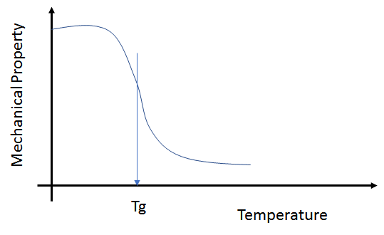

(c) Briefly discusses the advantages of this approach as compared with the Differential Scanning Calorimetry (DSC) method, [**30 marks**]

The DSC method/instrument measures the thermal capacity of the sample, which at Tg does not change significantly**,** so for complex multicomponent samples it could be difficult to detect changes in heat capacity.